# **Assignment 1: Linear Algebra, Probability and Statistics**

**Tapaswi Satyapanthi**

[**satyapanthi.t@northeastern.edu**](mailto:satyapanthi.t@northeastern.edu)

## **Question 1**

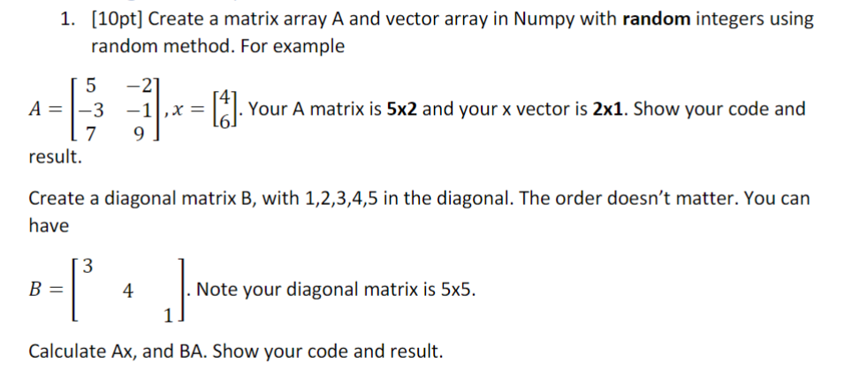

**Code with Result:**



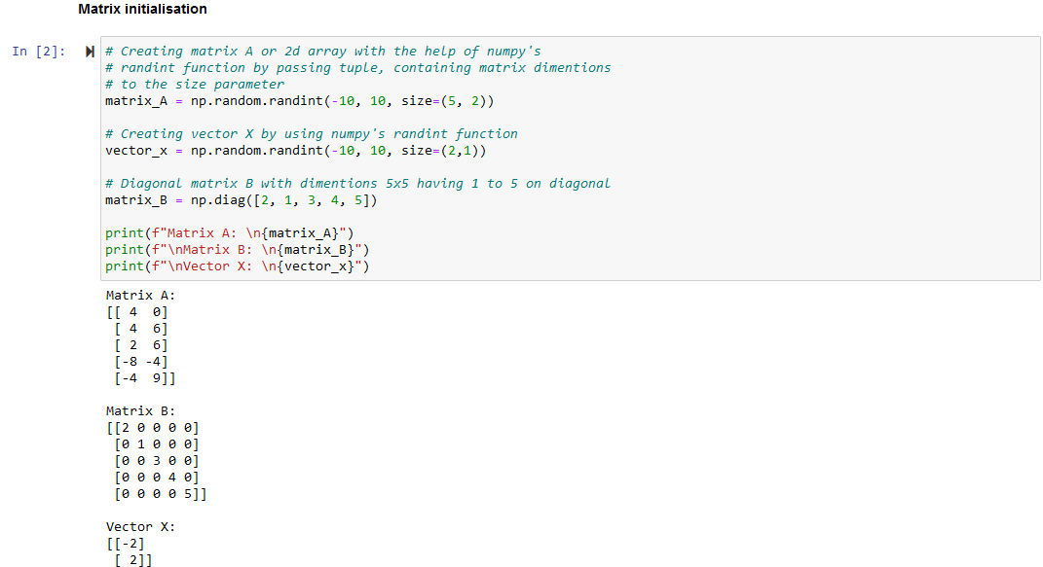

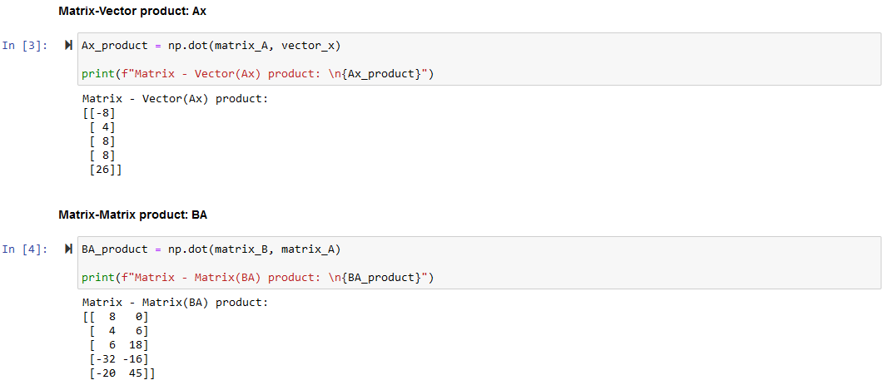

## **Question 2**



**Code with Result:**

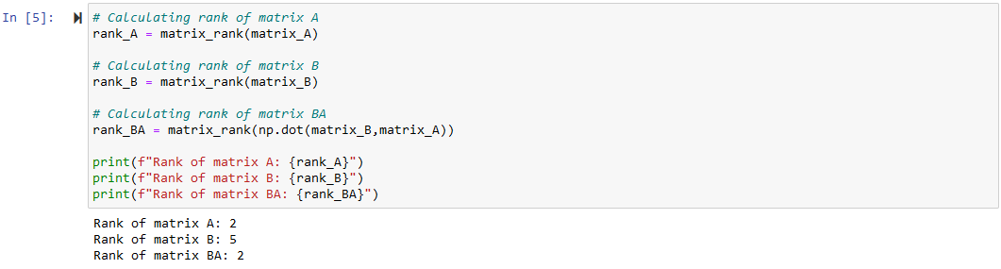

**What about the rank of BA? Are they different? Why?**

Here rank of the matrix *BA* is not equal to the rank of matrix *B* but equal to the rank of matrix *A* because the *rank(BA)* is determined by the following relationship:

*rank(BA)* is minimum of the ranks of the matrices *B* and *A* i.e. *rank(BA) <= minimum(rank(B), rank(A))*

Hence, the rank of matrix *BA* will not be *5*, same as matrix *B*, because the minimum of the ranks of *B* and *A* is *2*, the rank of the matrix *A*.

So, the rank of the matrix *BA* *<= rank of A*, in this case equal to *A*, i.e. *2*.

## **Question 3**

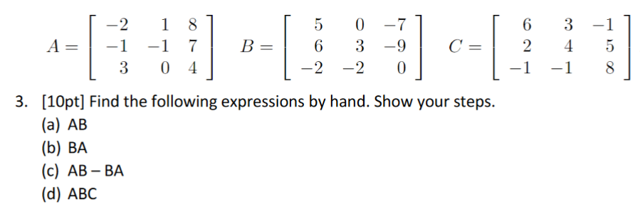

### **(a)**

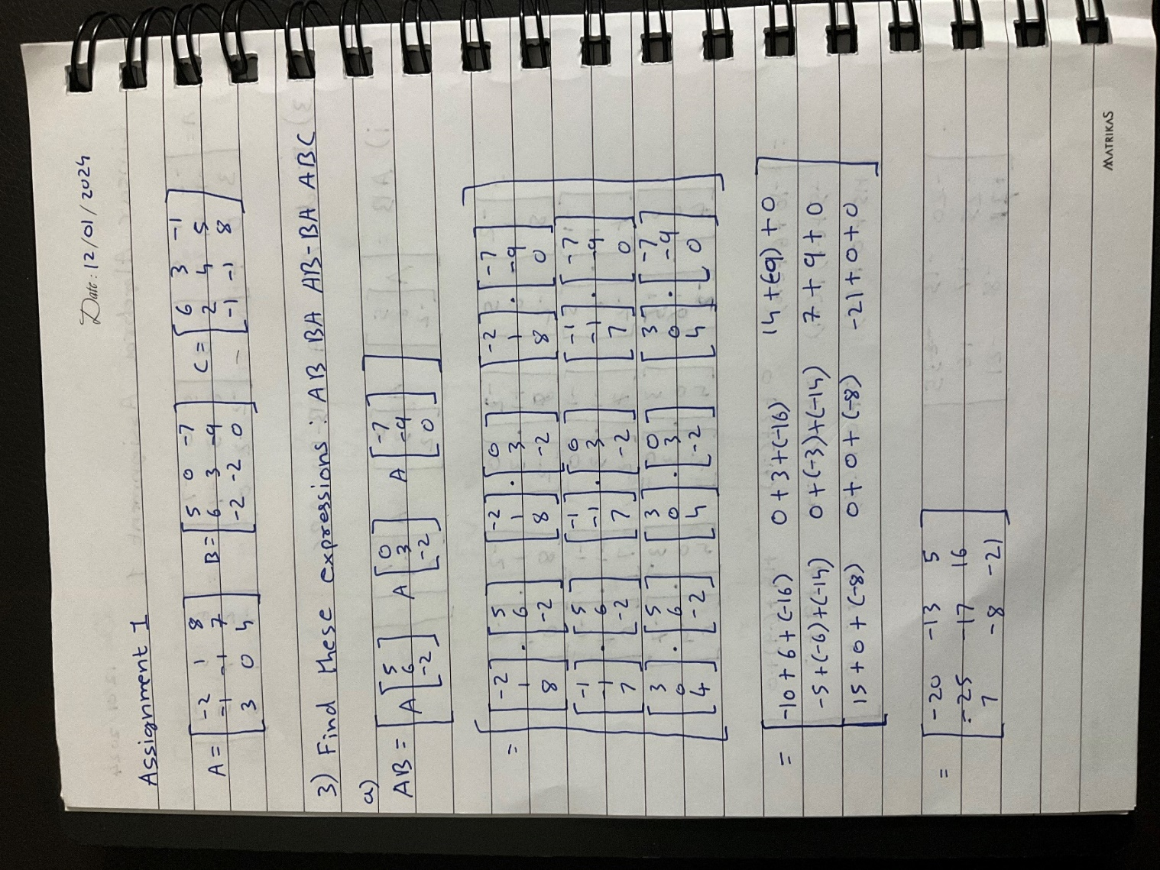

### **(b)**

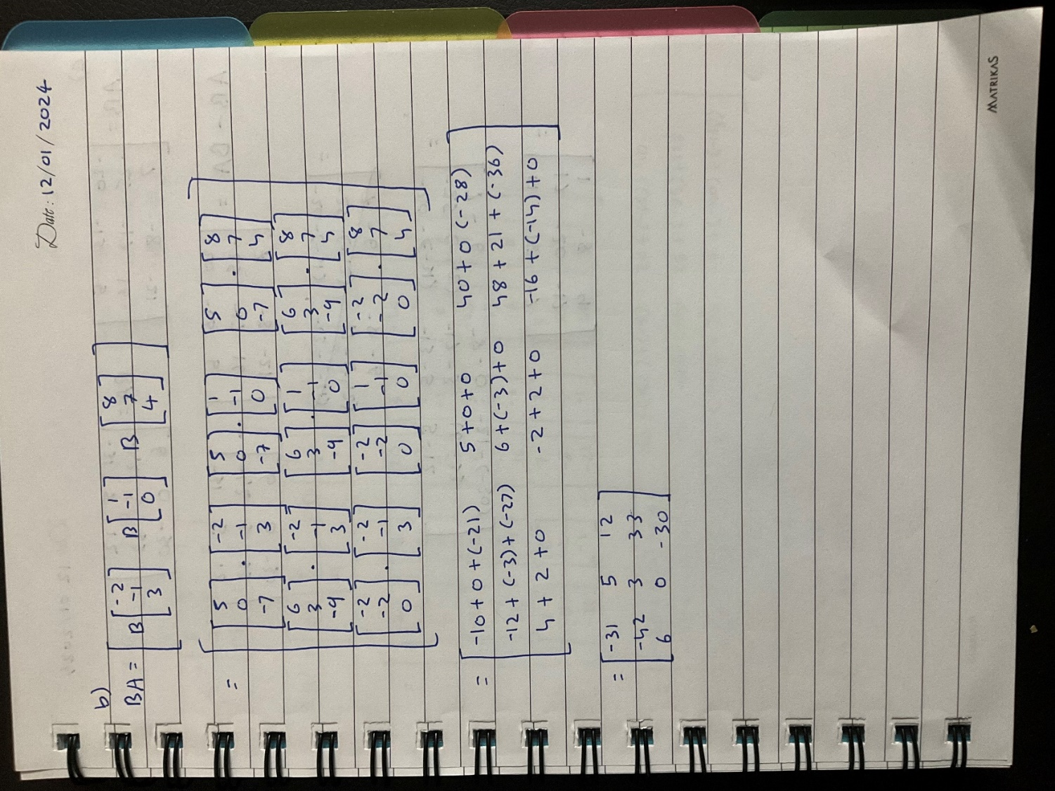

### **(c)**

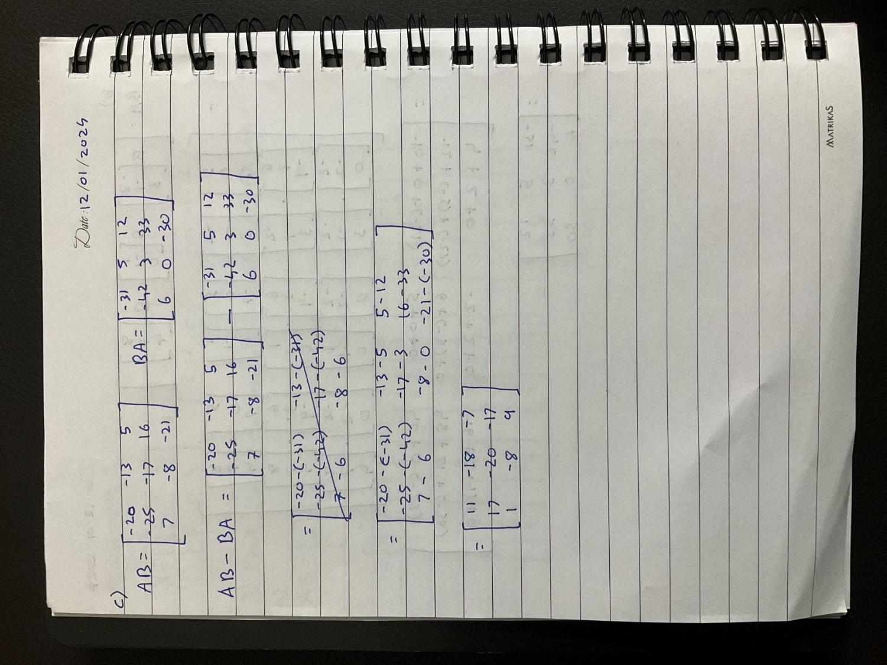

### **(d)**

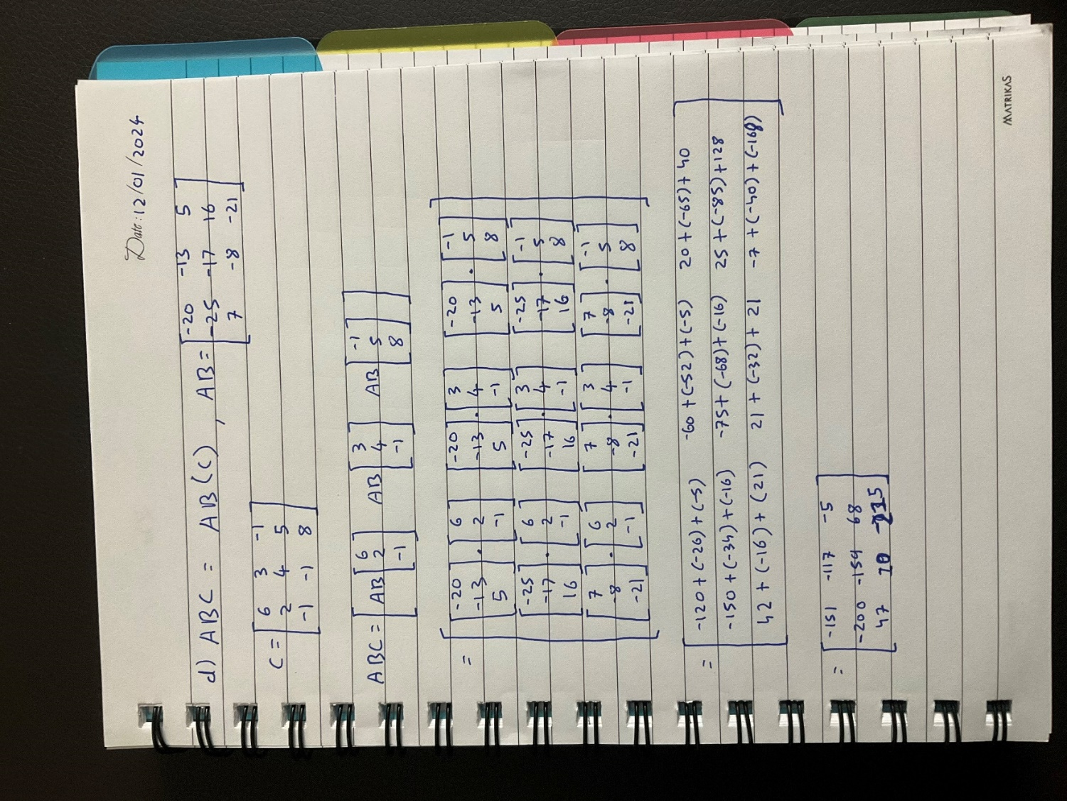

## **Question 4**

## **Question 5**





